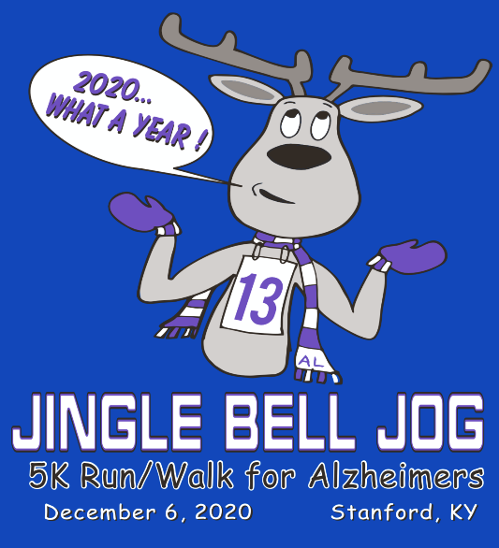
SUNDAY,
DECEMBER 6th
2:30
(Registration is 1:00-2:15pm)
Christian Life Center
204 Church Street
Stanford, KY 40484

****GIFT TO ALL****
run/walkers
who completes the race

13th ANNUAL
FREE NECK GATOR FOR ALL ENTRIES R’CVD BY 11/6 @ MIDNIGHT

Non-refundable entry fee:
$20 min. from every entry given the
Alzheimer’s Association

Received by December 5th –

Race shirt only - $20.00

1/4 zip (tech fabric)

only option - $35.00

Race shirt & 1/4 zip

(tech fabric) - $45.00

Race Day Entries – add $5.00

Extra neck gator - $10.00

Extra ¼ zip (tech fabric) - $30.00

Mail check (made payable to Jingle Bell Jog) and entry form to:
Jingle Bell Jog
Box 325
Stanford, KY 40484

(or drop off at State Farm Insurance in Stanford)
Age Divisions: 12-Under / 13-17 / 18-24 / 25-29 / 30-34 / 35-39/ 40-44 / 45-49 / 50-54 / 55-59 / 60-64 / 65-69 / 70-74 / 75-79 /80-84/ 85+
Medals will be given for 1st, 2nd and 3rd place in each Male and Female Age Group.
Overall Male and Female Master and Grand Master

~ TEAM SPIRIT AWARD ~
Awarded to largest group entered and present at 5K. Team Spirit Categories: Business,
Non-Profit, & Family

Questions? Call: (859) 333-8498 / Email: stanfordjinglebelljog@yahoo.com

Stanford Jingle Bell Jog 2020 Entry Form

Name:

Phone:

Address: City/State/Zip:

Date of Birth: _____________ AGE DAY OF RACE___
Email:

Sex (circle one): | M | F | Shirt Size (circle one): YOUTH - YMD YLG | ADULT -SM MD LG XL 2XL XXL
 |  |  | (circle one) DRI-FIT or COTTON | (circle one) DRI-FIT or COTTON
SHIRT ONLY-$20 _____ ¼ ZIP ONLY-$35_____ SHIRT & ¼ ZIP-$45_____ EXTRA GATOR-$10_____ EXTRA ¼ ZIP-$30_____

My entry is a donation only, I will not participate in the 5K Team Name:

Category (Circle one): Business Non-Profit Family Team

Participant Waiver (Please read and sign below)
In consideration of you accepting this entry, I, the participant, intending to be legally bound and hereby waive or release any and all right and claims for damages or injuries that I may have against the Event Director and all of their agents assisting with the event, sponsors and their representatives and employees for any and all injuries to me or to my personal property. This release includes all injuries and/or damages suffered by me before, during or after the event. I recognize, intend and understand that this release is binding on my heirs, executors, administrators, or assignees. I also authorize the use of photographs or videos that include my image for promotional, informational, or other reasons to be in the best interest of this event. I certify as a material condition to my being permitted to enter this race that I am physically fit and sufficiently trained for the completion of this event and that my physical condition has been verified by a licensed Medical Doctor. By submitting this entry, I acknowledge (or a parent or adult guardian for all children under 18 years) having read and agreed to the above waiver. I voluntarily seek to participate in the Stanford Jingle Bell Jog 5K run/walk for Alzheimer’s, a road race, as well as any other voluntary ancillary activities and therefore acknowledge that I am increasing my risk of exposure to the Coronavirus/COVID-19.
I acknowledge that I must comply with all set procedures to reduce the spread while attending the Stanford Jingle Bell Jog 5K run/walk for Alzheimer’s. I acknowledge the contagious nature of the Coronavirus/COVID-19 and that the CDC and many other public health authorities recommend social distancing. I further acknowledge that Stanford Jingle Bell Jog 5K run/walk for Alzheimer’s has put in place preventative measures to reduce the spread of the Coronavirus/COVID-19, but Stanford Jingle Bell Jog 5K run/walk for Alzheimer’s cannot and is not guaranteeing that I or a loved one will not become infected with the Coronavirus/COVID-19 or any other disease or sickness. I understand that the risk of becoming exposed to and/or infected by the Coronavirus/COVID-19 may result from the actions, omissions, or negligence of myself and others, including, but not limited to, race staff, race volunteers, contractors, supporters, and other runners and their family.
I am not experiencing any symptoms of illness such as cough, shortness or breath or difficulty breathing, fever, chills, repeated shaking with chills, muscle pain, headache, sore throat, or new loss of taste or smell.
I do not have a temperature of 99.5 degrees Fahrenheit or higher.
I have not traveled to a highly impacted area with in the United States of America in the last 14 days.
I do not believe that I have been exposed to someone with a suspected and/or confirmed case of the Coronavirus/COVID-19.
I have not been diagnosed with Coronavirus/COVID-19 and not yet cleared as non-contagious by state or local public health authorities.
I am following all CDC recommended guidelines as much as possible and limiting my exposure to the Coronavirus/COVID-19.
I hereby release and agree to hold Stanford Jingle Bell Jog 5K run/walk for Alzheimer’s, the Alzheimer’s Association, the City of Stanford, the Stanford Baptist Church (for the use of their Christian Life Center) and all related parties, affiliates, sponsors, contractors, vendors, staff, and volunteers and fellow participants harmless from, and waive on behalf of myself, my heirs, and any personal representatives any and all causes of action, claims, demands, damages, costs, expenses, and compensation for damage or loss to myself and/or property that may be caused by any act of the race or any related entities, or that may otherwise arise in any way in connection with any services received form the Stanford Jingle Bell Jog 5K run/walk for Alzheimer’s and all related parties form any liability or claim that I, my heirs, or any personal representatives may have against the race and its related entities with respect to any bodily injury, illness, death, medical treatment or property damage that may arise from, or in connection to, any services received from the Sanford Jingle Bell Jog 5K run/walk for Alzheimer’s. The liability waiver and release extends to all owners, partners, representatives, volunteers and employees.

Participants Signature (parent or guardian if under 18): ____________________________________ Date:_______________

