****GIFT TO ALL****
run/walkers
who completes the race

***********
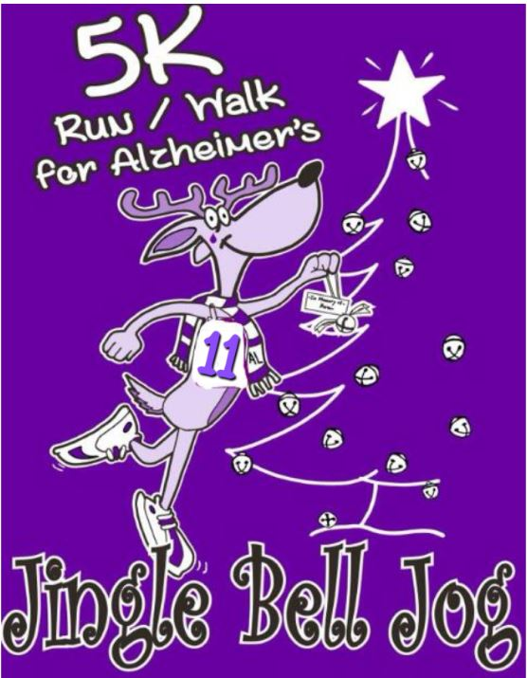
12

SUNDAY
*********** DECEMBER 8th
***********
2:30

12th Annual
Main Street ~ Stanford, KY www.stanfordjinglebelljog.org

2:30 PM
(Registration will be from 1:00-2:15pm)
Christian Life Center
204 Church Street
Stanford, KY 40484
Non-refundable entry fee:
100% given to the Alzheimer’s Association

Received by December 7th - $20.00

Race Day Entries - $25.00

Make checks payable to: Jingle Bell Jog
Mail check and entry form to:
Jingle Bell Jog PO Box 325
Stanford, KY 40484
(or drop off at State Farm Insurance in Stanford)
Age Divisions: 12-Under / 13-17 / 18-24 / 25-29 / 30-34 / 35-39/ 40-44 / 45-49 / 50-54 / 55-59 /
60-64 / 65-69 / 70-74 /75-79 /80-84/ 85+
Medals will be given for 1st, 2nd and 3rd place in each Male and Female Age Group.
Overall Male and Female Master and Grand Master winners
~ TEAM SPIRIT AWARD ~
Awarded to largest group entered and present at 5K. Team Spirit Categories: Business, Non-Profit, & Family

Questions? Call: (859) 333-8498 / Email: stanfordjinglebelljog@yahoo.com

----------------------------------------------------------------------------------------------------------------------------------------------------------------------------
Name:
Phone:

Address: City/State/Zip:

Date of Birth:_____________ AGE DAY OF RACE___
Email:

Sex (circle one): | M | F | Shirt Size (circle one): YOUTH - YMD YLG | ADULT -SM MD LG XL 2XL XXL
 |  |  | (circle one) DRI-FIT or COTTON | (circle one) DRI-FIT or COTTON
My entry is a donation only, I will not participate in the 5K Team Name:

Category (Circle one): Business Non-Profit Family Team

Participant Waiver (Please read and sign below)
WAIVER in consideration of the acceptance of this entry, I hereby, for myself, my heirs, executors, administrators and assigns, and anyone entitled to act on my behalf, release and forever discharge the Jingle Bell Jog Committee, plus sponsors, their representatives and successors, promoters, managers, directors, officials, agents, employees and volunteers of the Jingle Bell Jog from any and all claims of injury or liabilities of any kind, illness or dangers suffered by me as a result of my participation in or travelling to or from the event. I know that running or walking a road race is a particularly hazardous activity. I should not enter and run or walk unless I am medically able and properly trained. I agree to abide by any decision of a race official pertaining to my ability to safely complete the run or walk. I assume all risks associated with running or walking in this event, including, but not limited to, falls, contact with other participants, the effects of the weather (including rain and/or snow), traffic and the conditions of the road, all such risks being known and accepted by me. I realize that this is a strenuous event which requires proper physical conditioning. I hereby certify that I am in such physical condition and in good health. I also give permission for the free use of my name and picture in any written account, broadcast or telecast of this event for any legitimate purpose.

_ | _
Participant Signature______________________________________________ | Date______________________ | Parent/Guardian Signature (If participant is under 18)

